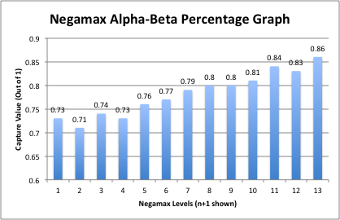(Was not able to format x-axis => It goes from 0 – 12)

Sharath Byakod

Period 4

2/20/18